**JAVASCRIPT-Scalar**

1. **Introduction:**

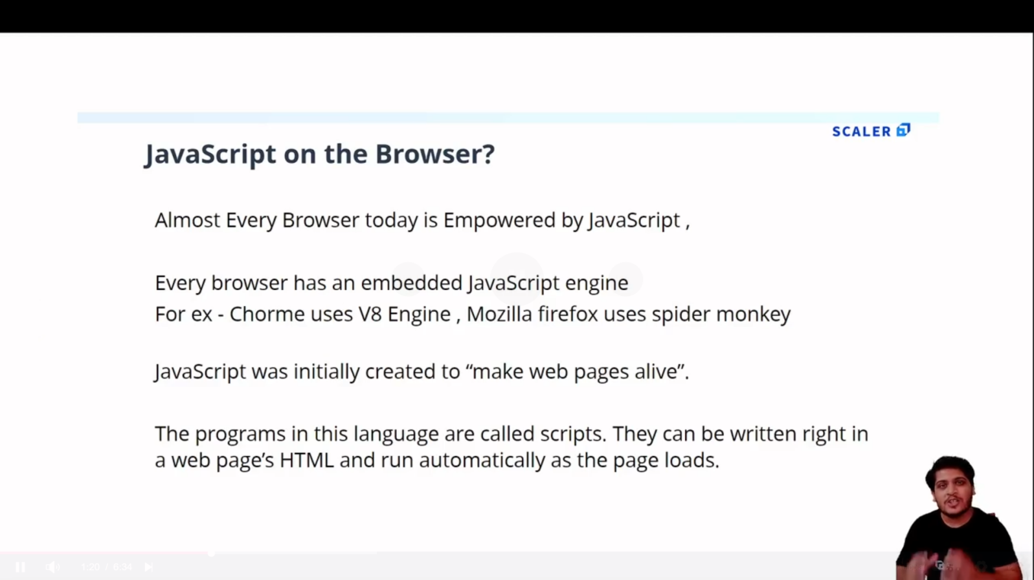

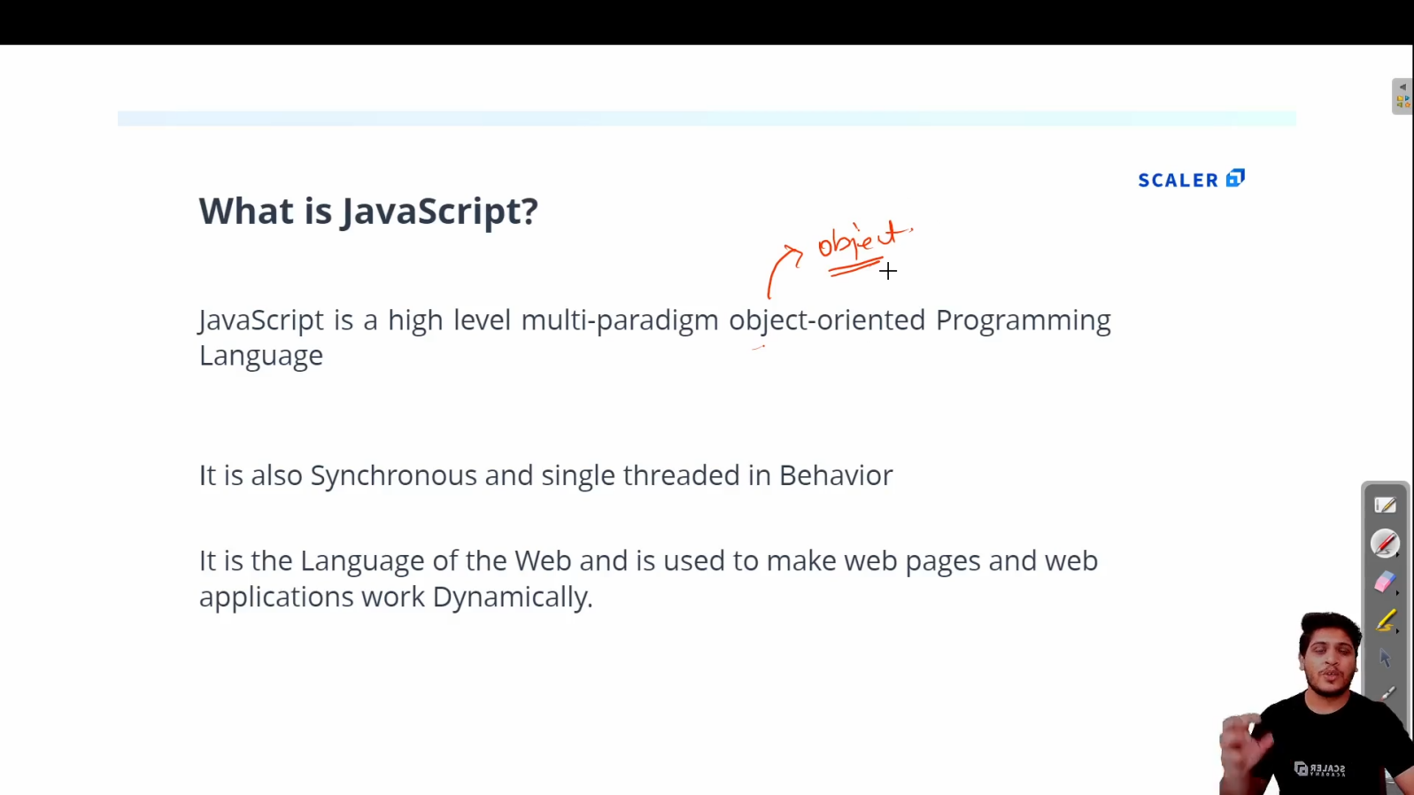

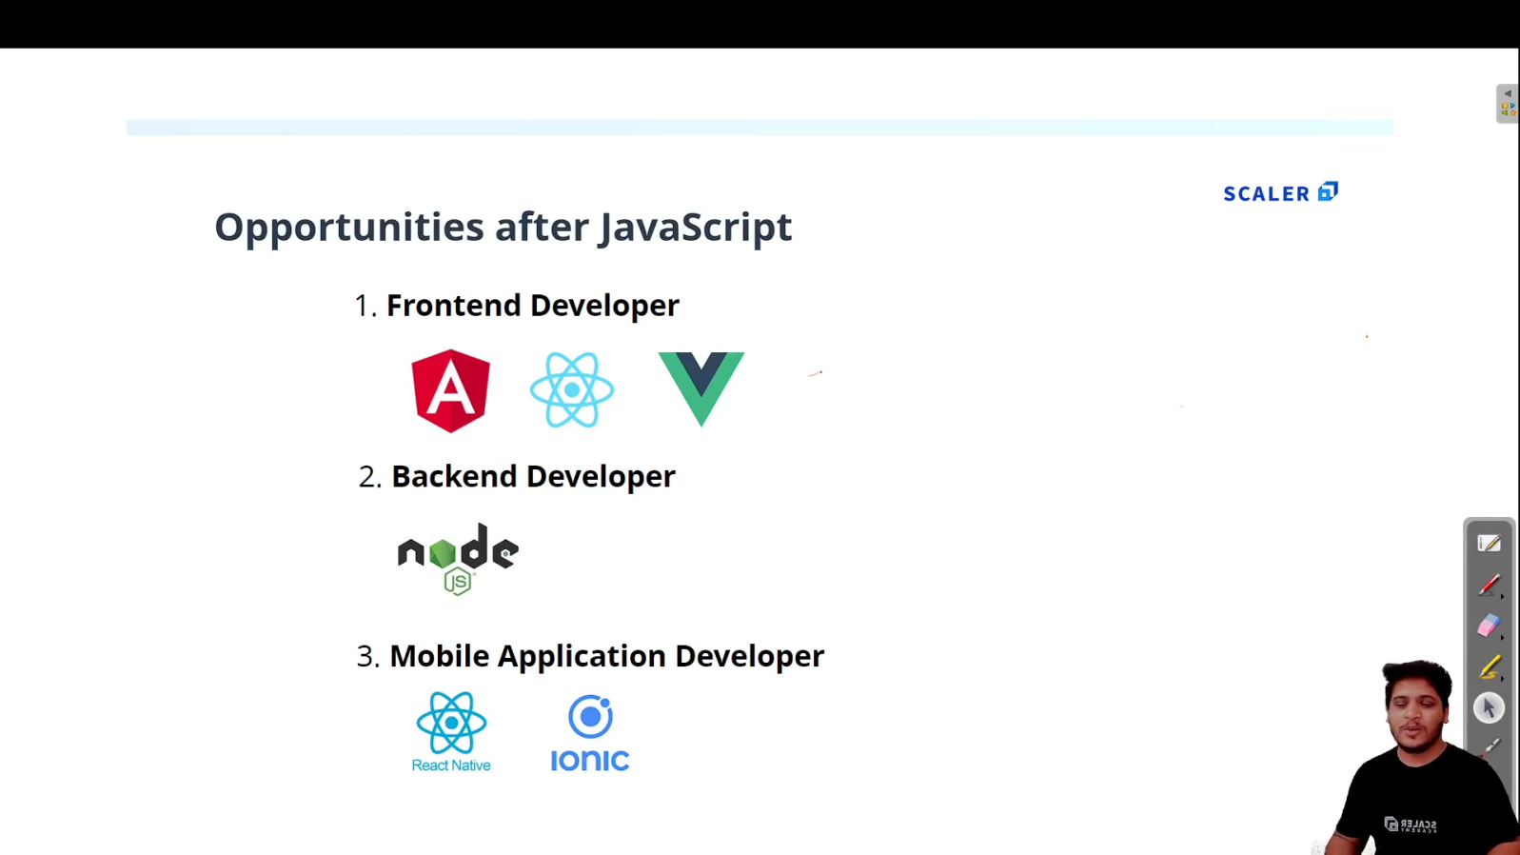

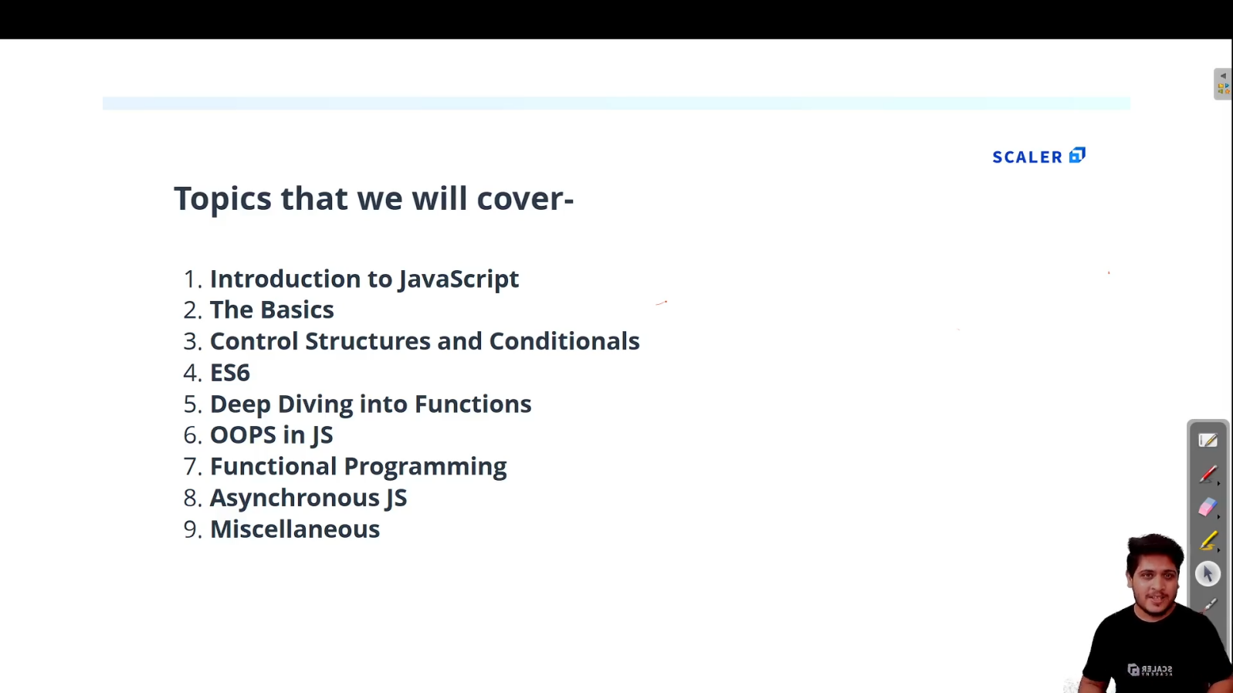

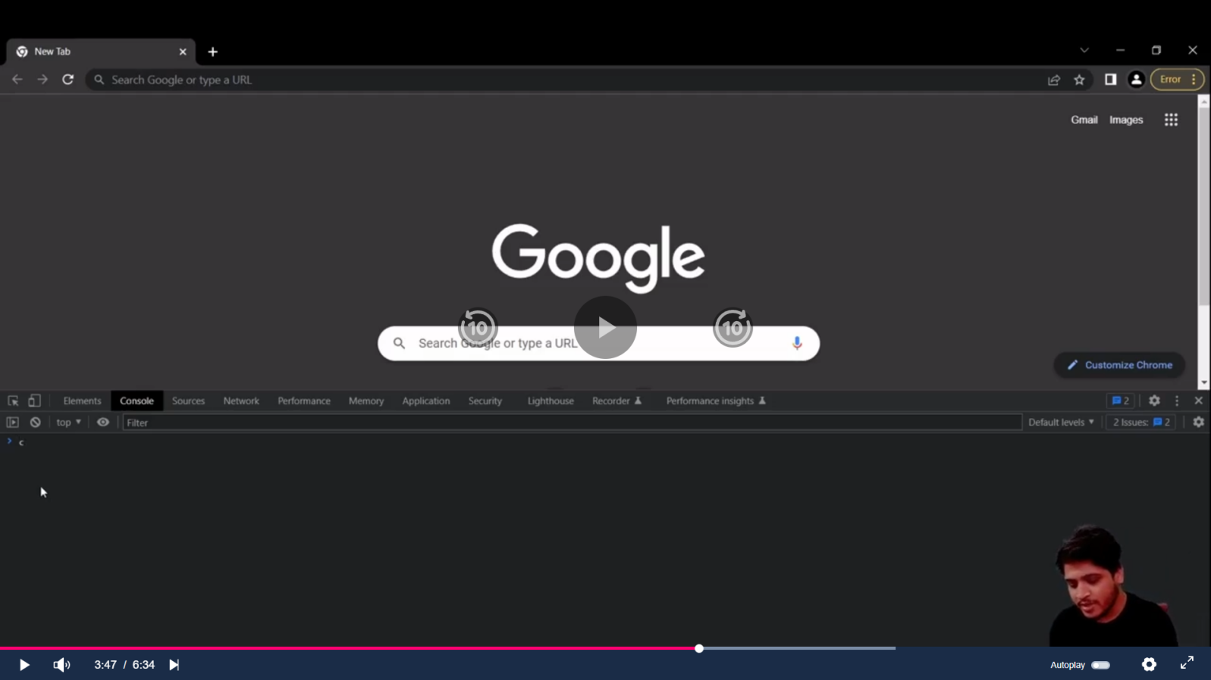

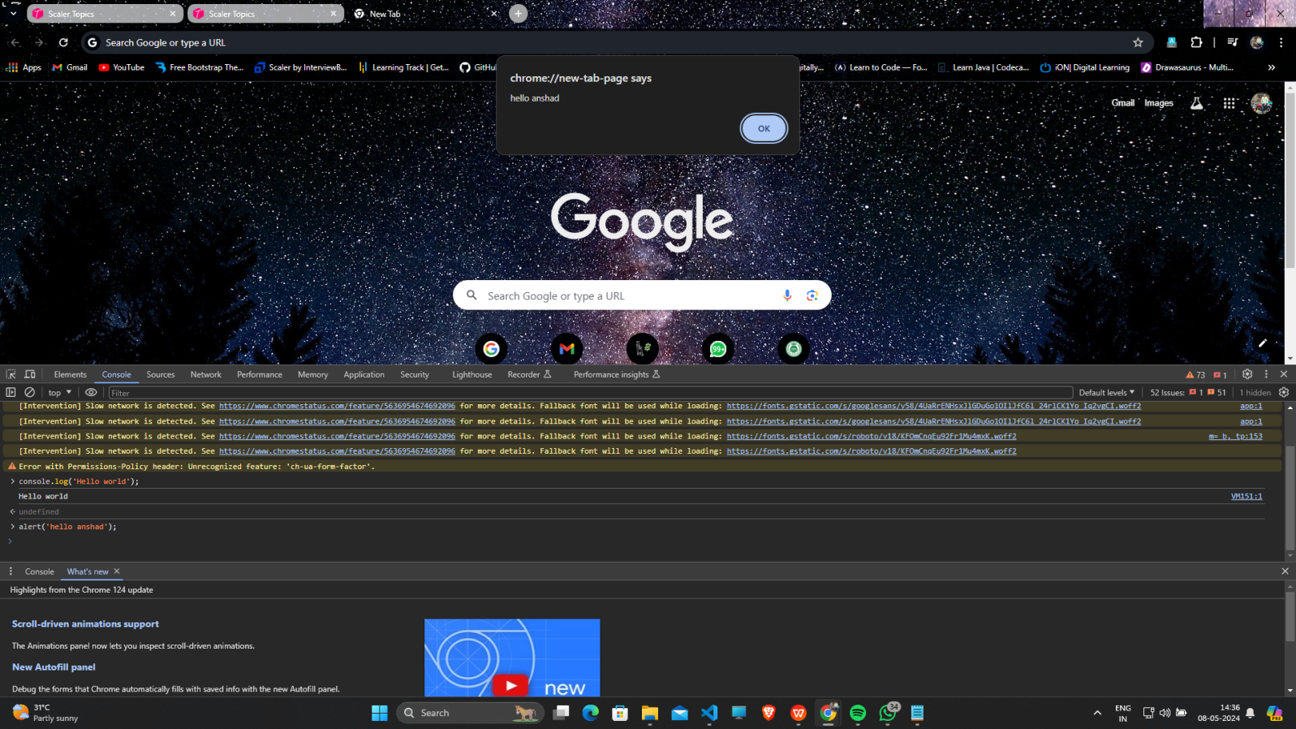

1. **First JS program :**
   1. **Create index.html and script.js file**

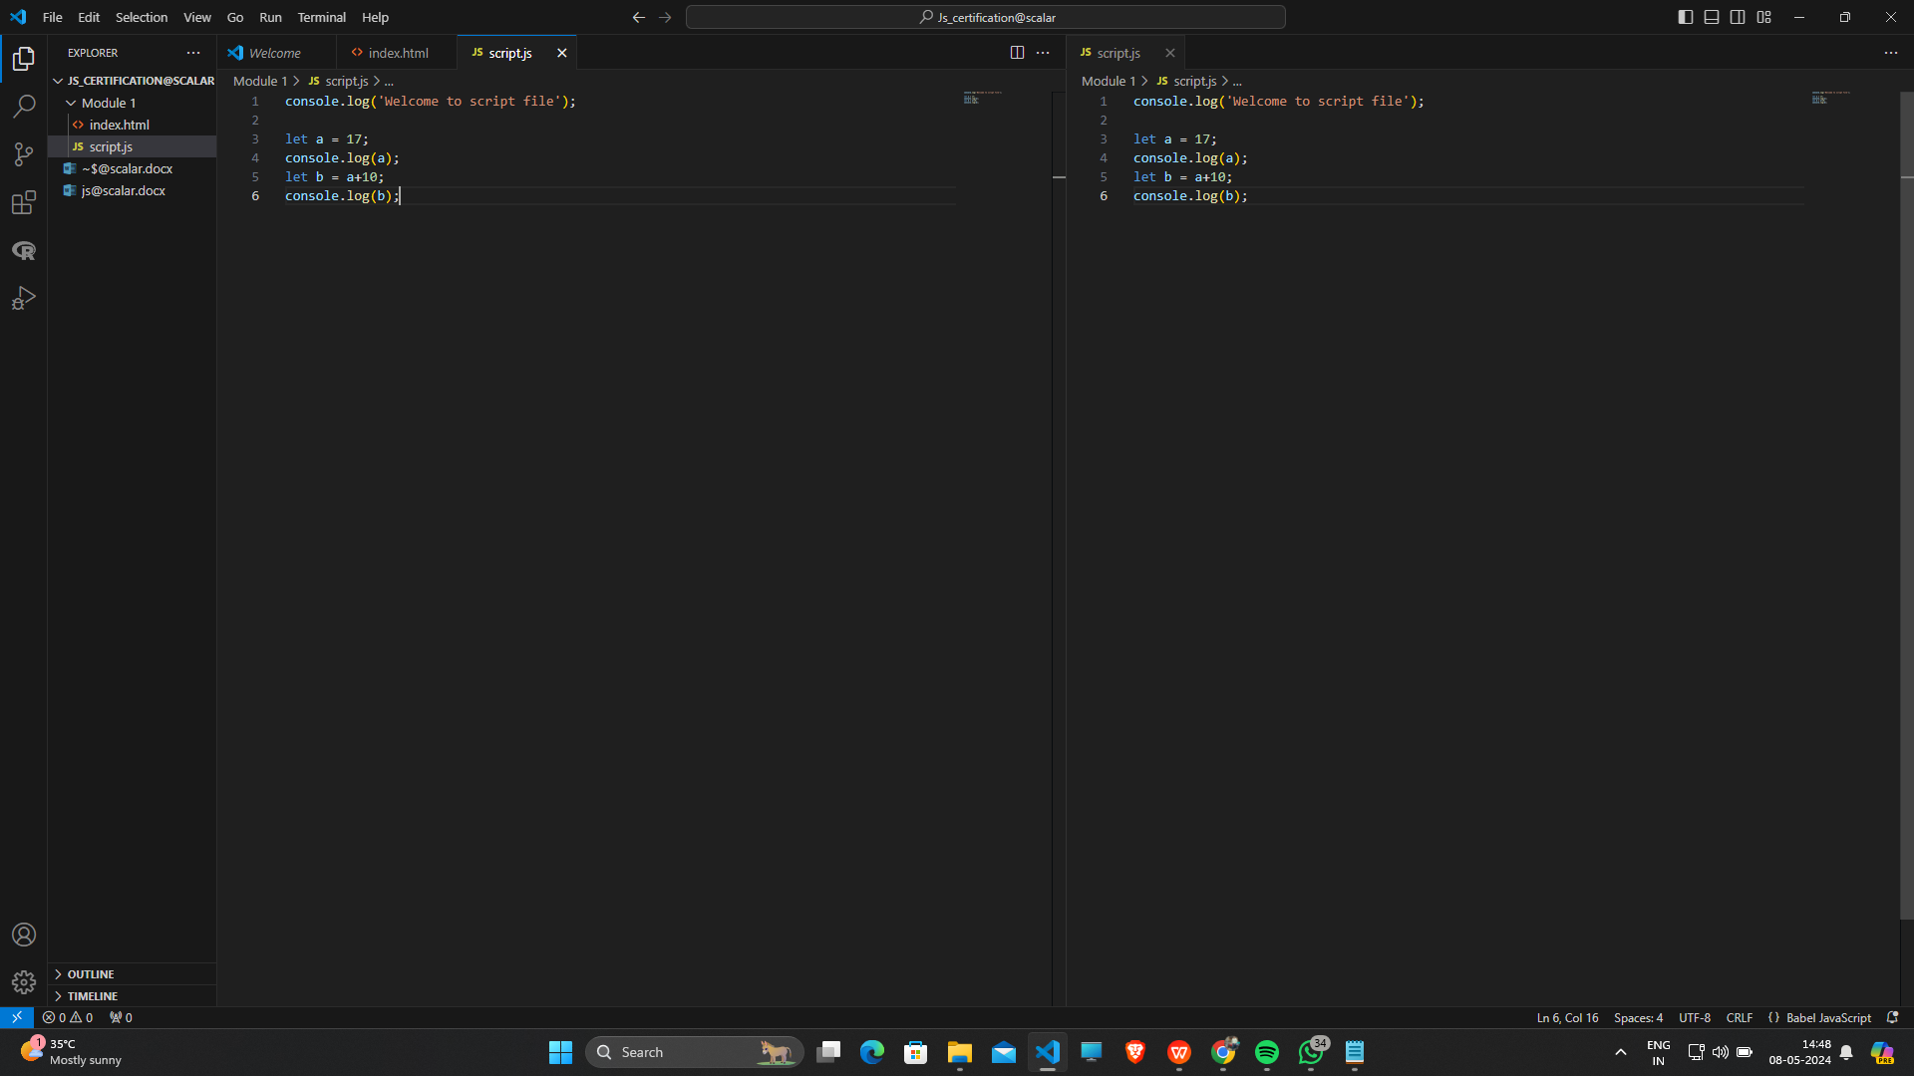

* 1. **To see Output ,open that index.html and inspect and go to console option :**

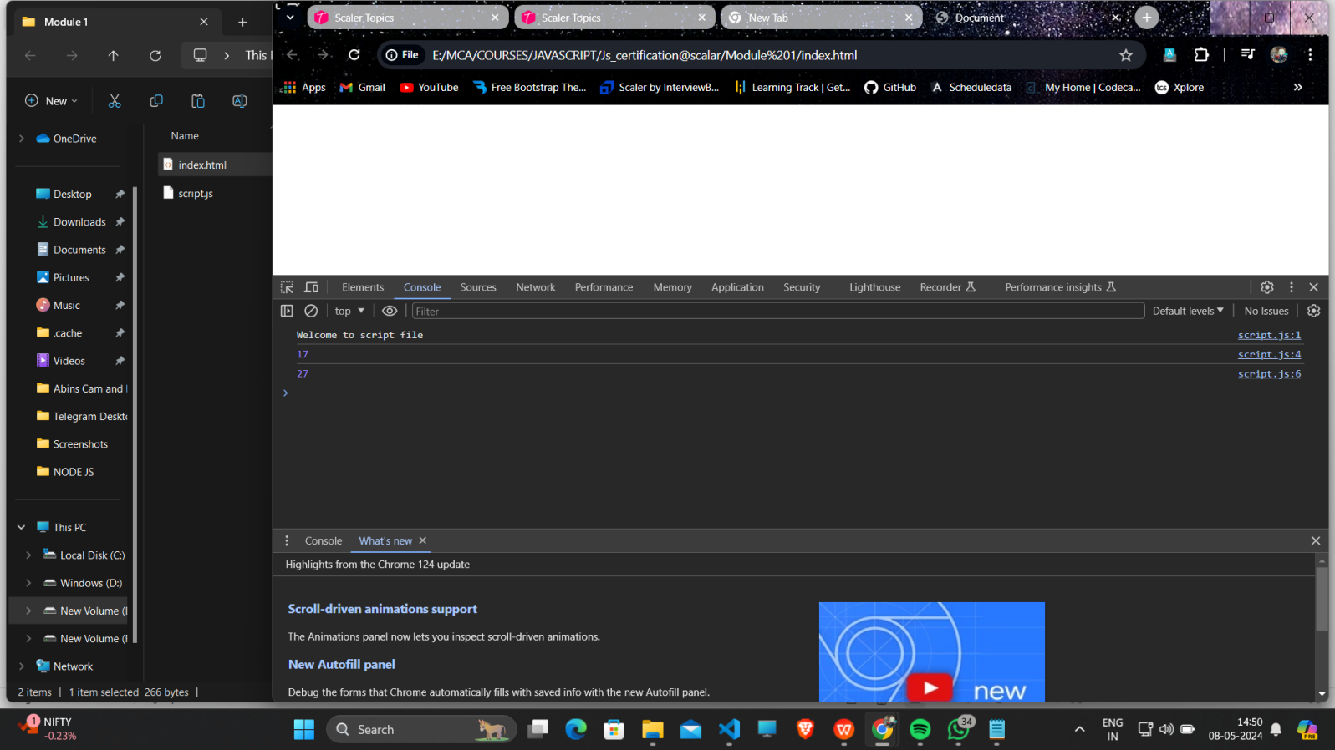

* 1. **Add an “Live Server” Extension to VScode so you can right click and select Open with Live Server ,which will directly take you to browser.**

1. **Variables in JS :**

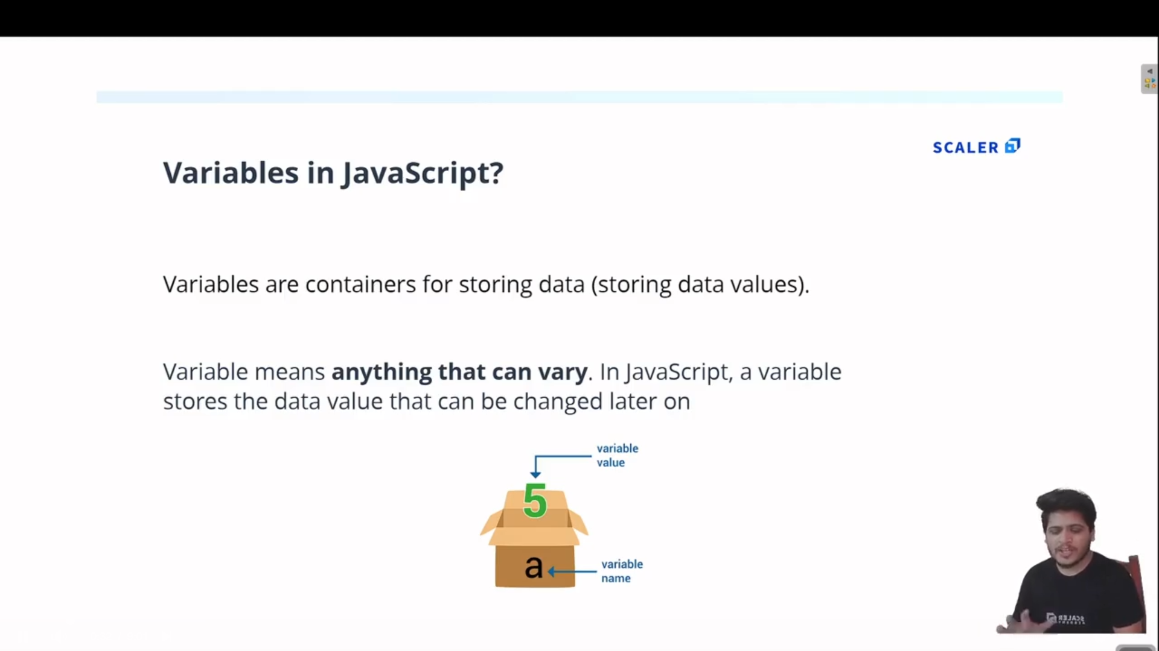

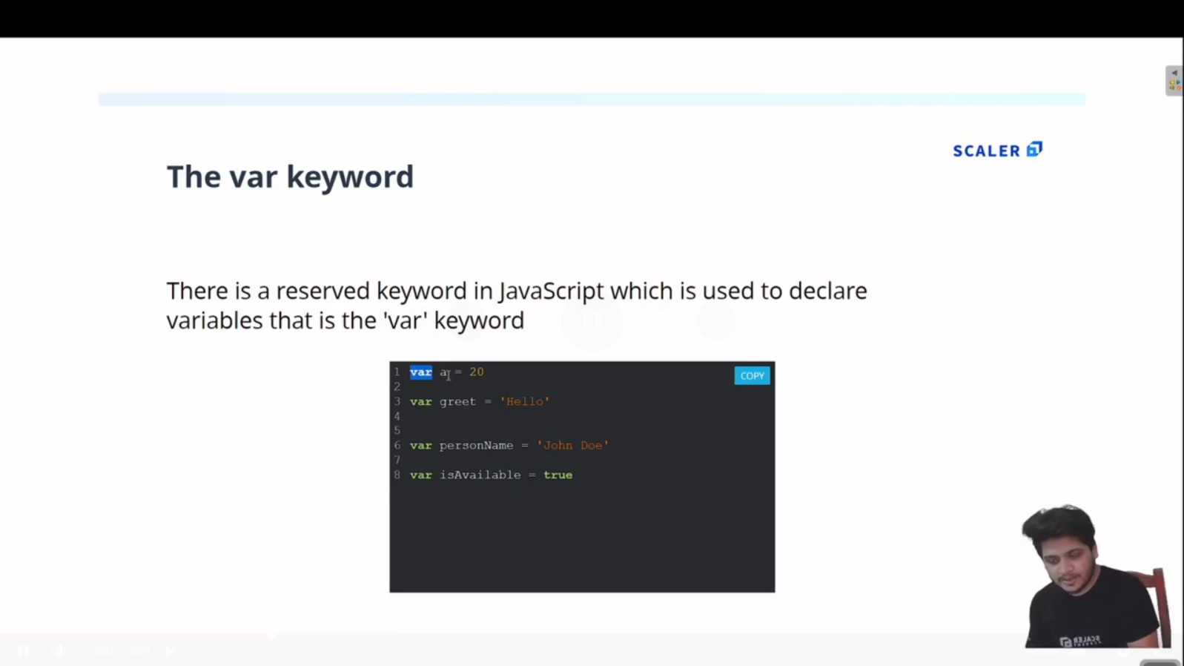

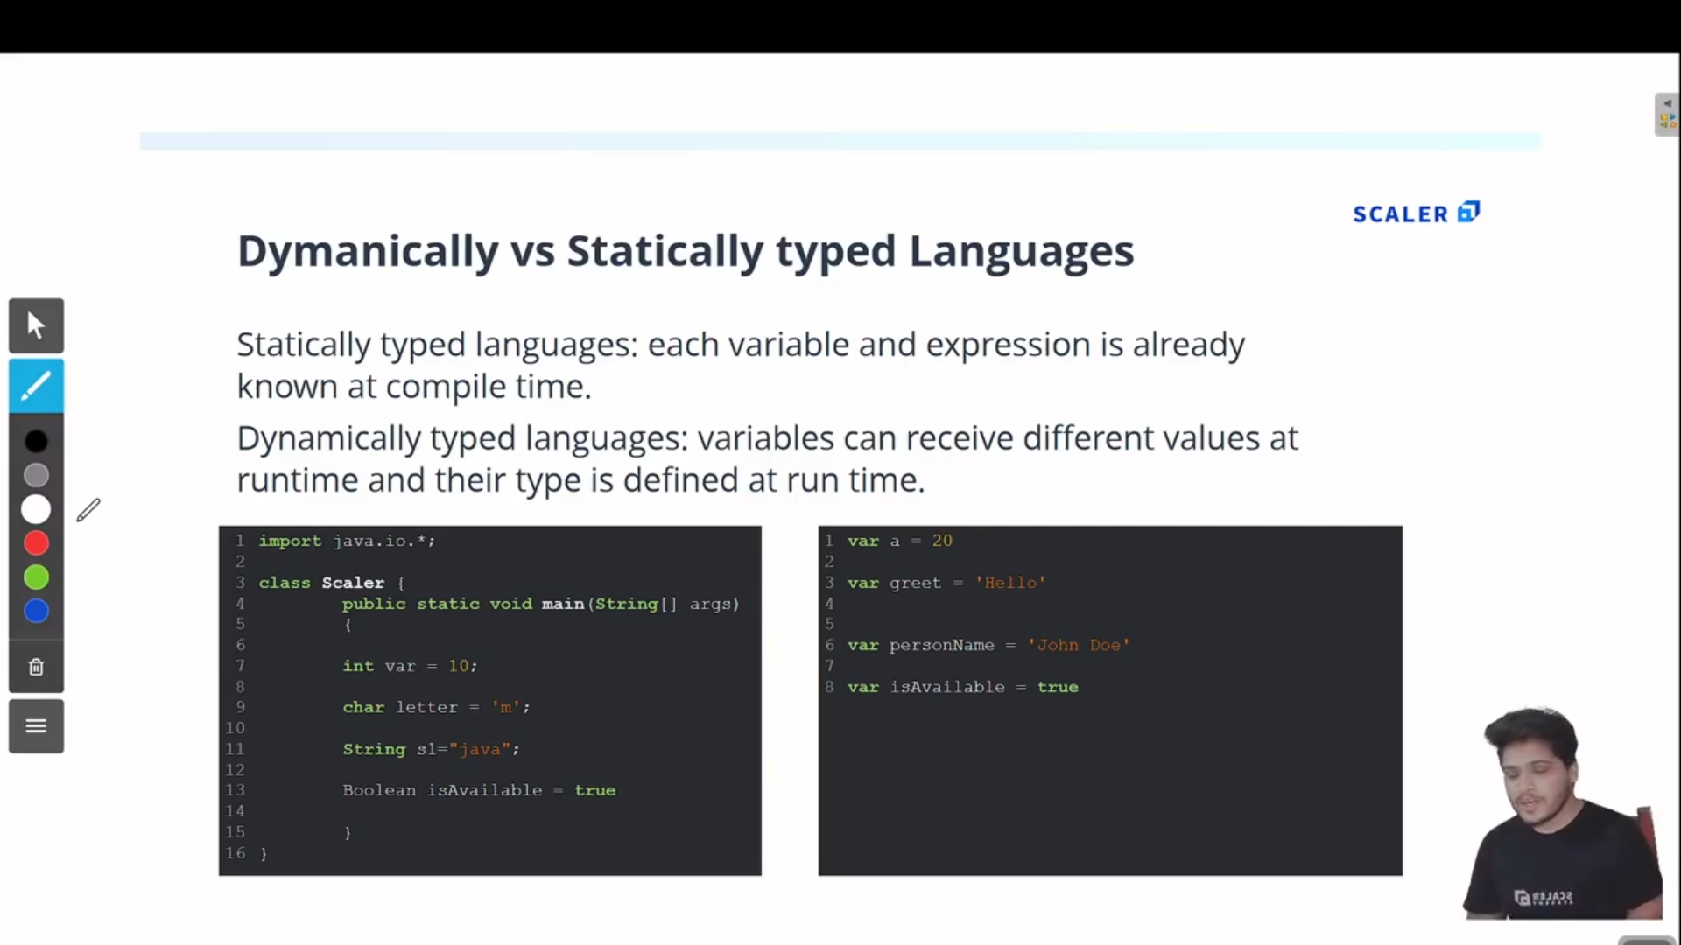

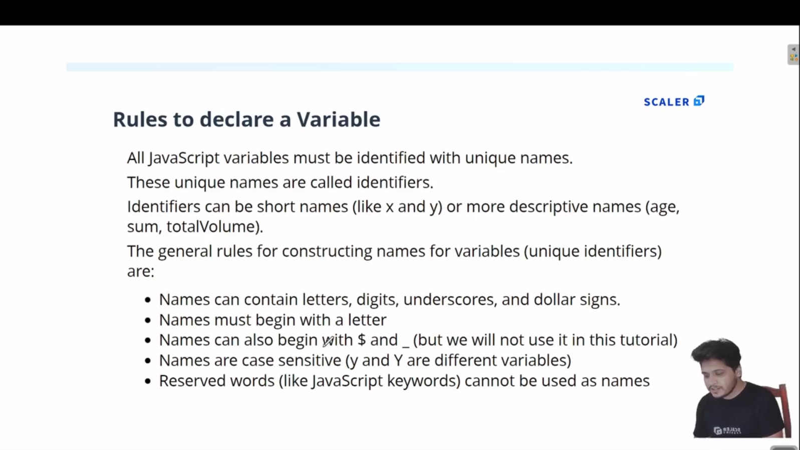

1. **Arrays in JS:**

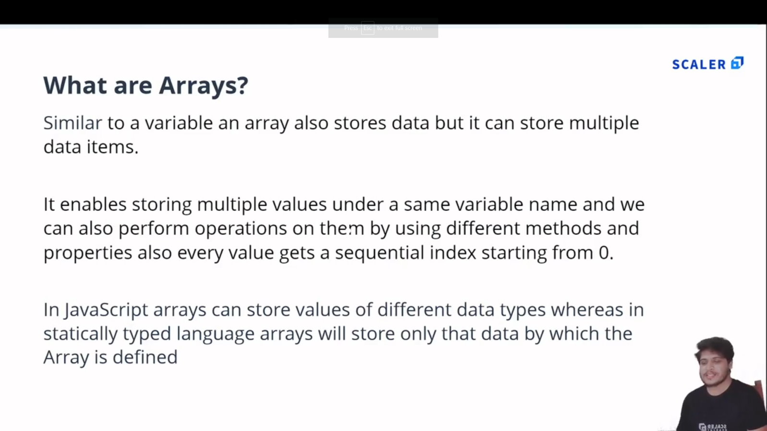

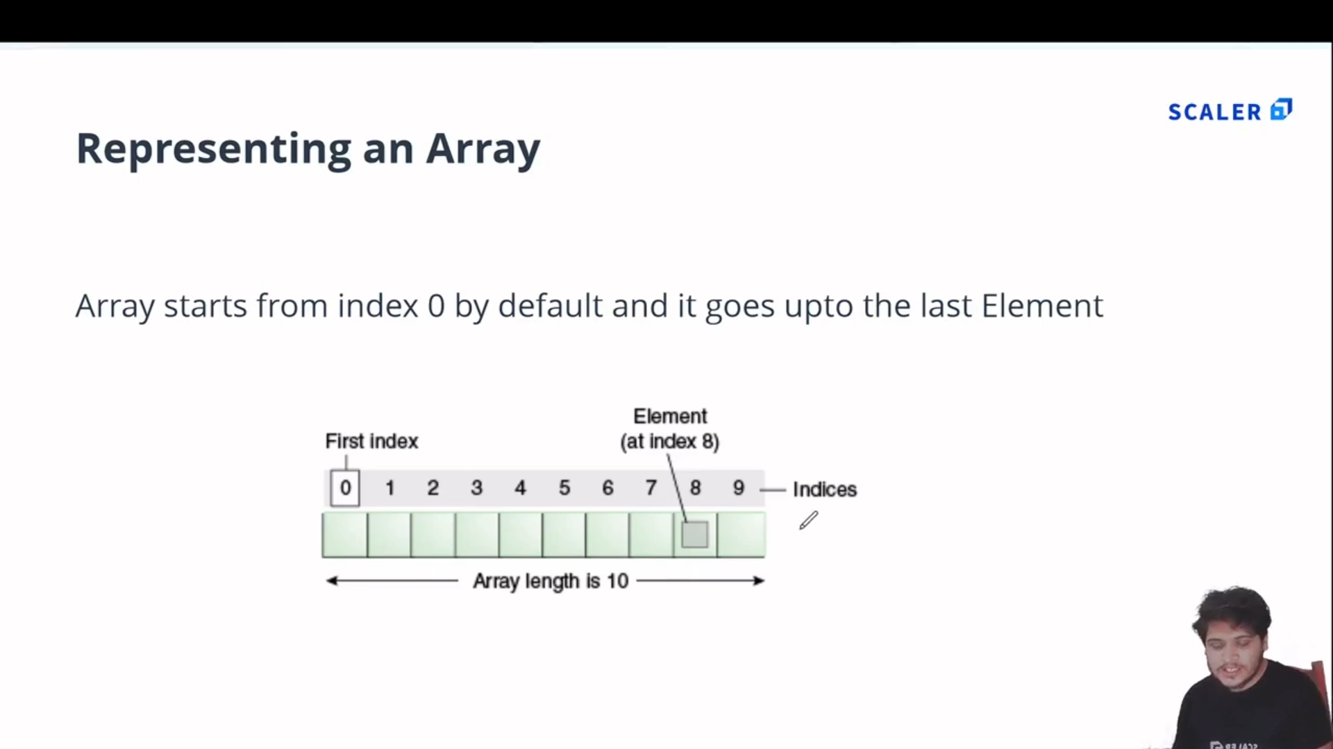

* 1. **Example:**

//Array : In JS Array can store multiple values of differnt datatypes

var arr = [12, 'Ferrari' , true , 12.4];

console.log(arr);

//Accessing Elements

var a = arr[0];

console.log(a);

//replacing array elememt

arr[1] = 'Bently';

console.log(arr[1]);

//length property

console.log('Length of array is : '+arr.length);

**Output:**

[Running] node "e:\MCA\COURSES\JAVASCRIPT\Js_certification@scalar\Module 2\array.js"

[ 12, 'Ferrari', true, 12.4 ]

12

Bently

Length of array is : 4

* 1. **Output:**

1. **Array Methods :**
2. **Dsa**
3. **Asd**
4. **Asd**
5. **asd**